Deliverable report
Agreement number: SI2.488704 (ECOKT2016-1)
Project name: Learner-centred digital ecosystem of competence development (Compleap)
Date: 28.6.2018
Work package: WP2
Title: Task-force and WP2 meetings and meeting notes
Author: EDUFI (Annica Moore)
Description of the action:

WP2 activities and the planning of the prototypes has been arranged around 3 thematic Task Forces:
- Architecture and interoperability (TF-AI)
- Personal learner plan (TF-PLP)
- Learning environments and analytics (TF-LEA)
The work of each task Force was divided both in workshops and meetings, and in constant discussion with the project Management Team.

Outcome of the action:

The report below details the work of the three Task Forces, as well as the way in which the work is continuous throughout the course of the project. Through active Task Force work, and cross-fertilisation between task forces we have inter alia laid out the architectural framework for service development, created user scenarios, initial mock-up prototypes, and reference group engagement plans for the CompLeap prototype modules, as well as planned the data sources for running learning analytics within the services.

WP2 and Task Force Meetings
  - CompLeap -project; Spring 2018
  - EDUFI

This document details the preparatory meetings for planning CompLeap prototypes, as well as details the plans for going ahead. The Task Forces will continue meeting throughout the prototype development phase as the prototypes are being developed using iterative service design methods.
The below details the meeting leading up to the development of the first Mock-up prototype.

Set-up of WP2

The work in WP2 Requirements and architecture design has been divided in three sections, relating to the three Task Forces identified already in project preparation phase:

- Defining Service Architecture
- Defining User Needs for Services
- Defining Data Needs in Services

WP2 work on prototype definition will continue through out the WP3 prototype development phase together with the developers, users as well as WP4 through the use of iterative service design methodologies.

Defining the Service Architecture – Task Force 1: Architecture and interoperability (TF-AI)

Mapping the service architecture was lead by CSC, the core team being Ari Rouvari, Antti Laitinen, Jonna Korhonen and Anna Lindfors.
The architecture work laid the foundation upon which the new services can be positioned. As such this section of the project was participated in by a large section of the project team.
The way of working was to work around modelling. in each weekly meeting the framework architecture model was re-worked and updated during the meeting.
The visualizing work was done by enterprise architect Ari Rouvari with QPR visualizing tools.
The first images were worked on in Finnish after which the final architecture models were created for project use in English.
Preparatory meeting dates and participants:
- 28.12.2017: Antti, Jonna, Anna, Ari
- 2.1.2018: Antti, Jonna, Anna, Ari
- 8.1.2018: Antti, Jonna, Anna, Ari
- 18.1.2018: Anna, Antti, Ari

Joint EDUFI and CSC workshops resulting in Framework Architecture Models
- February 1st, 2018. With participants: Ulla Angervo, Seppo Ränninranta (Senior Architect), Katariina Männikkö, Katarina Repo (EDUFI System Architect), Annika Grönholm (EDUFI), Marcus Caselius (EDUFI), Merja Väistö (EDUFI), Paula Borkowski, Risto Hanhinen, Anna Lindfors(CSC) and Ari Rouvari (CSC)

- February 13th 2018. With Ulla Angervo, Seppo Ränninranta (Senior Architect), Katariina Männikkö, Katarina Repo (EDUFI System Architect), Annika Grönholm (EDUFI), Marcus Caselius (EDUFI), Merja Väistö (EDUFI), Paula Borkowski (EDUFI), Risto Hanhinen (EDUFI), and Ari Rouvari (CSC)

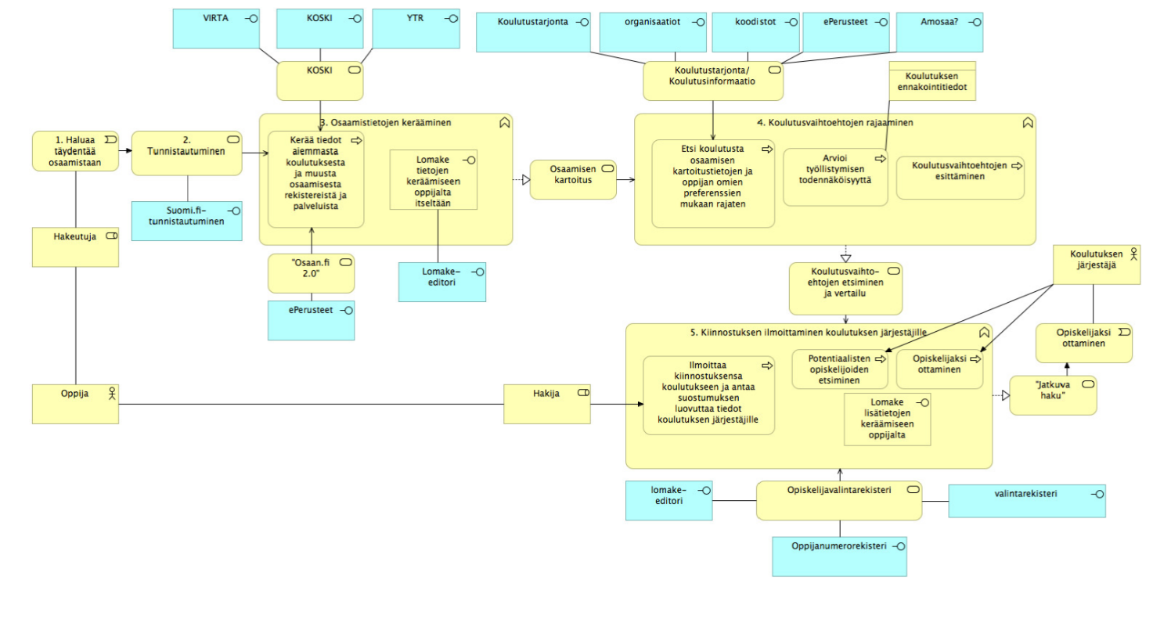
Figure 1: Initial service framework imagery on user scenarios (in Finnish only)

Through meetings and as a result of two EDUFI – CSC workshops the Task Force summed up the service framework as detailed below:

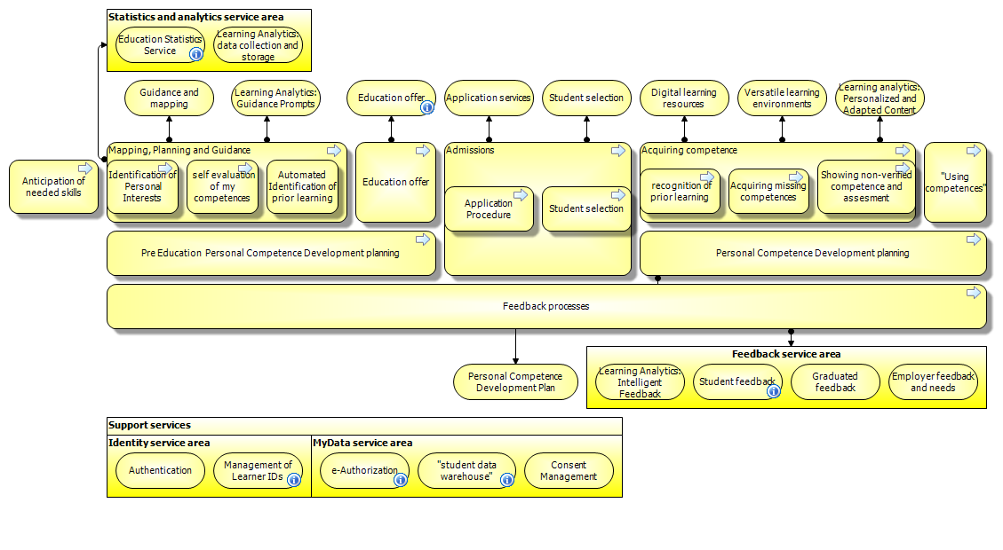
Figure 2: CompLeap Service Framework Architecture

All architecture images are stored in the architecture bank and the idea is to update the models throughout the project.
The feedback and ideas is collected from the different national and international stakeholders and reference group joining the Compleap work. The basic idea is to build a framework architecture for EU-use which could help in developing digital services in different EU-countries. The framework should sum up the services in general level that are dealing with the competence development and help in identifying the possible needs in services.

Defining User Needs and Services – Task Force 2: Personal learner plan (TF-PLP)

The Task Force 2 (TF-PLP) way of working was organised around wider workshops and task force meetings.

The prototype design task force has included the following experts:
Marcus Caselius, EDUFI (Joint task force lead)
Paula Borkowski, EDUFI (Joint task force lead)
Annica Moore, EDUFI
Anni Silvola, Uni. Oulu
The detailed prototype planning was kicked-off at the April 9th Stakeholder kick-off seminar. The premise was that invited experts and key stakeholders could both validate needs identified through the architecture work and provide concrete feedback on user needs for prototype definitions and components.
The prototype design task force compiled all ideas collected at the stakeholder kick-off workshops and started to re-work them into detailed scenarios for the developers.
The meetings were as follows:

EDUFI Planning Workshops 29.3. and 4.4. for user needs definition. Meeting results: planning and fine-tuning stakeholder engagement plans and ways of working at user needs definition workshops. Participants: EDUFI Services for Learners unit
EDUFI Kick- off Workshop 17.4. on way forward. Meeting results: Timetable and work plan
Participants: Ulla Angervo, Katariina Männikkö, Katarina Repo (EDUFI System Architect), Annika Grönholm (EDUFI), Marcus Caselius (EDUFI), Merja Väistö (EDUFI), Paula Borkovski (EDUFI), Risto Hanhinen (EDUFI), and Anni Silvola (via distance).
· Task Force meeting 19.3 preparations for the stakeholders’ seminar, updating architecture picture and planning next steps together with task force 3
· Task Force meeting 18.4. translating stakeholder workshop ideas into user requirements for prototypes. Meeting results: all workshop ideas regrouped, initial needs analysis for prototype development
· Task Force Meeting 25.4. further developing prototype user scenarios. Meeting results: translating needs into user initial scenarios for developers
· Task Force Meeting 2.5. discussing and consolidating html prototype development plans with developers. (1) Preliminary Prototype needs identified: Creating a Competence Profile with strong identification; (2) Creating a Competence Profile for NEET/Immigrants; (3) Open expression of interest to competence development linked to personal interests
· Task Force Meeting 3.5. further defining roles and responsibilities for core team. Meeting Results: better division of labour in Task Force.
· Task Force Meeting 7.5. Utilising current Oulu university user research for prototype definitions. Meeting results: research on user needs better included in mock-up prototypes, incl:
- Importance of easy to find and concrete information on prospective paths, salary, type of employments
- Visualisations rather than text
- Versatile information about educational opportunities and paths, different occupations, and different working positions
- Competence mapping as the tool to provide added value to user
- Availability of register data
· Task Force Meeting 14.5. on Mock-up prototype. First tests with preliminary mock-up prototype, providing feedback to developers.
· Task Force Meeting 6.6. on next service design steps with Cybercom. Meeting Results: Decisions on landing page + four modules Education, Experience, Strenghts and Skills, Ambitions. Goal is to get a draft which visualizes the learner path in general level.
· Task Force Meeting 18.6 Descriptions of different user profiles and differencies in their user needs, resulting a table where different user needs are described. In collaboration with WP4 and Task Force 3

Defining Data and Analytics Needs in CompLeap Services – Task Force 3: Learning environments and analytics (TF-LEA)

Much of the Task Force 3 (TF-LEA) work has coincided with TF-PLP meetings, as analytics will be intertwined in the Learner Path being developed. This work has been guided by regular meetings between the University of Oulu and EDUFI.
The core Task Force for defining analytics needs in the CompLeap architecture has been Hanni Muukkonen, Jouni Pursiainen and Anni Silvola at the University of Oulu. Additionally, EDUFI experts have provided input and guided the work of the Task Force when needed.
Stakeholder and reference group input is vital to understand and configure user needs for learning analytics. This is why TF-LEA has been incremental also in planning stakeholder and reference group engagement.
Task force meeting 20.2 Problem idenfitification for learning analytics needs, designing the process of designing learning analytics for the project
Task force meeting 26.2 Mapping different examples from previous research in order to present ideas for designing analytics for Compleap.
Task force meeting 14.3 Designing data collection for user needs definitions together with representatives of Vocational institution of Oulu area (Oulun seudun ammatillinen oppilaitos). Identification of the relevant users for interviews.
Task force meeting 17.4 Designing learning analytics features for user scenarios draft, focus especially on comparing educational opportunities
Task force meeting 20.4 Update meeting for research interview questions regarding the data collection for the user needs for learning analtics
Task force meeting 17.5 Mapping relevant data sources for learning analytics, picture of data sources for different elements of the service
Task force meeting 7.5 Check-up meeting for what has been done with learning analytics until that date and to what things to focus on next.
Task force meeting 8.5 First trials of creating a tag system in order to create recommendation system to the service
Task force meeting 15.6 in collaboration with TF-PLP and WP4, designing questionnaire for student councelors in order to collect data from user needs. Additionally, going through existing tools for competence mapping used in vocational education in Finland.
Additionally, AVAIN-research group met approximately once in a month, Compleap analytics solutions were discussed in meetings 14.2 and 13.3. Collaboration was done also with beginning project AnalytiikkaÄly, in which similar topics with Compleap are developed. Participation for the project meetings 16.5. 30.5 and 7.6.

As a result of task Force 3 work the following mapping of data used in the prototypes has been formed:

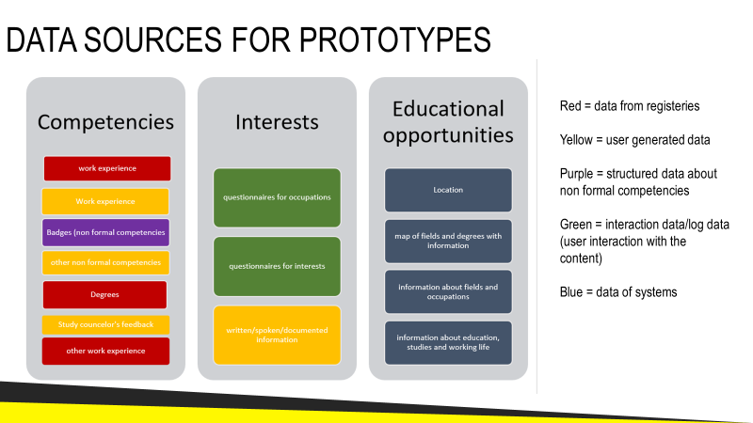

Figure 3: Data source for CompLeap prototypes

The Way Forward
User validation is ongoing in all the four phases of prototype development:
- Mapping architecture – initial mapping of current service framework
- Mock up prototype – visual screenshots of the modules for testing a concept (ongoing)
- HTML prototype – more functionalities than a mock up proto
- Beta-pilot – in a sense works almost like a final product

Currently we are further defining the mock-up prototype for more user testing, following which we will continue with Task Force meetings detailing the html-prototypes to be defined.
User testing and validation will be done throughout the course of the project. This will be done in cooperation with WP 4 and with reference groups. Regular reference group webinars will be held monthly in order to collaborate closely with key stakeholders and the reference groups formed during the initial phases of the project.
The First Webinar was held Tuesday June 19th at 9:30 - 10:30. A recording of the webinar can be found here: https://connect.funet.fi/pbdil44lrxmo/.
Fall 2018 Webinar dates:
- Thursday September 6th at 9.30-10:30
- Tuesday October 16th at 9.30-10:30
- Wednesday November 28th at 9:30-10:30
The webinars will include:
- updates and questions on progress with the prototypes,
- focus on specific project areas such as learning analytics,
- guest input from related services, such as Europass, or the Finnish labour market web platform Työmarkkinatori

RÉFERENCE GROUP WORKSHOP OCT 10th 2018 IN HELSINKI
Reference Group Workshop will take a closer look at the html prototypes, through this process we can gain valuable insights for their development.

